***INTERNETWORKING ESSENTIALS - CSE307***

***Section – K23UP Submitted by:***

***Aditya Nandan***

***Registration & Roll Number:***

***12307229, 54***

***DATE: - 03/03/2025***

***In partial fulfilment for the requirements of the award of the degree of***

***“B. Tech CSE Data Science and Machine Learning”***



***“School of Computer Science and Engineering”***

***Lovely Professional University***

***Phagwara, Punjab***

**Project54: You are hired as a network engineer for CS Network Solutions, a mid-sized enterprise with an eight-floor office building. Each floor is equipped with 6 computers, and the organization requires a well-structured network to ensure efficient communication and scalability.**

**Network Design Requirements:**

1. **Topology Selection: Design a star topology for first three floors, mesh topology for next two floors, and ring topology for remaining floors, considering performance and fault tolerance**
2. **IP Addressing Scheme: The company has decided to use Class A private IPv4 addresses for first three floors and then Class A public IPv4 addresses for remaining floors following a classful addressing scheme.**

* **Routing Strategy for Inter-Floor Communication & Connectivity: Recommend a routing approach that is dynamic for inter-floor communication**
* **. Design how the floors will be connected for seamless interdepartmental communication.**
* **Suggest the appropriate network devices (e.g., switches, routers, access points) and their placement.**
* **If using dynamic routing, suggest an appropriate routing protocol (e.g., RIP, OSPF, or EIGRP) with justification.**
* **If using static routing, define the static routes for efficient data flow.**
* **Specify the number of default gateways along with IP addresses.**

# How you created the physical scenario. Attach

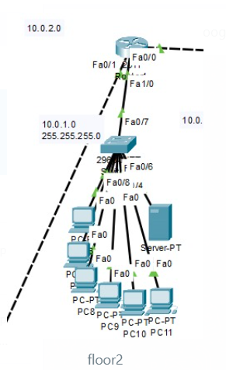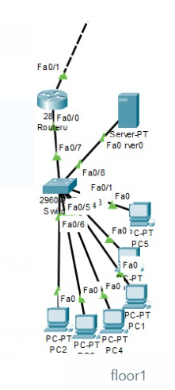

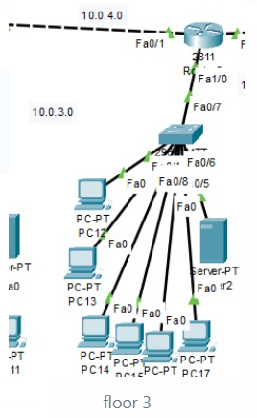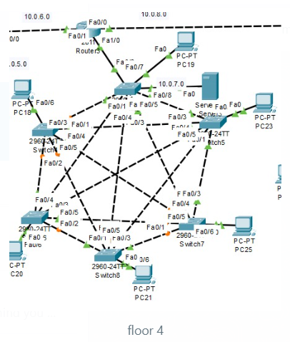

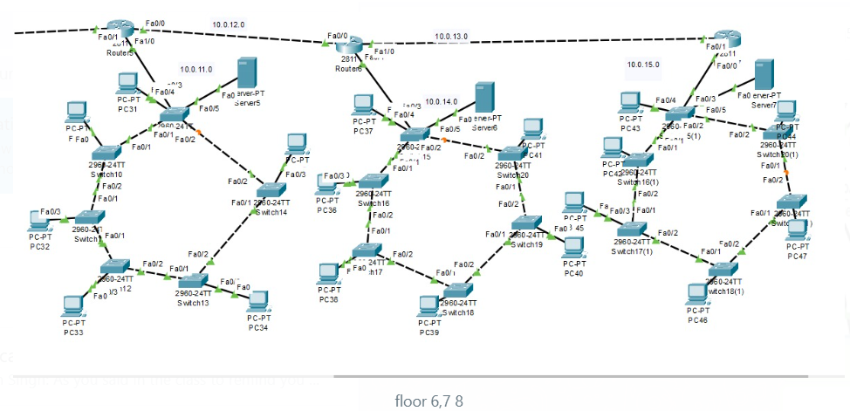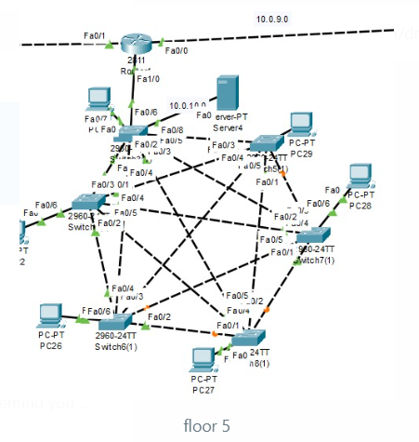

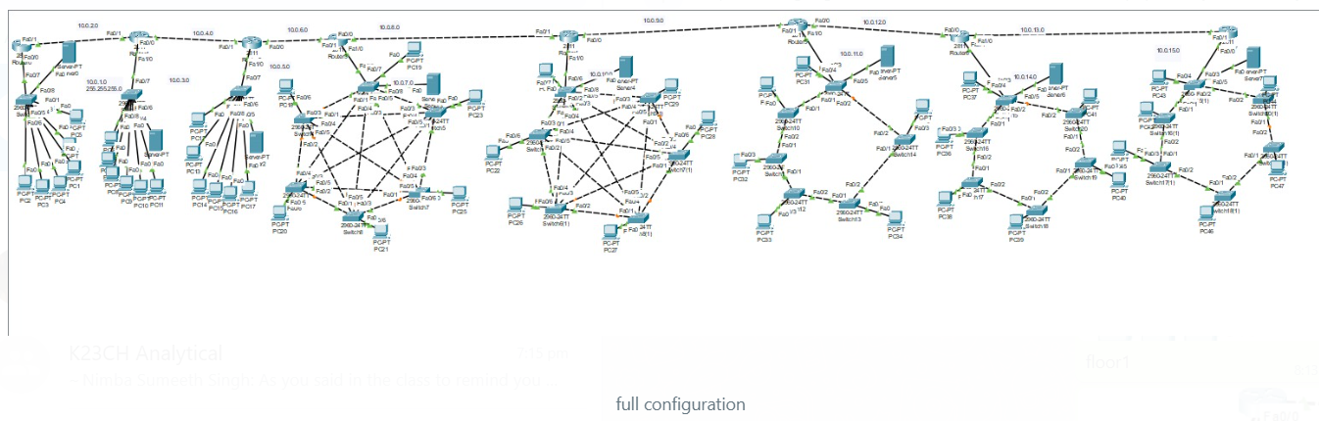

* **Number of Floor’s: -** 8 Floors
* **Type of Networking: -** Dynamic
* **Number of Topology’s: -** 3
* **Type of Topology: -** 1st , 2nd  and 3rd floor it’s star topology, 4th,5th floor its  **Mesh Topology**, 6th , 7th , 8 floor its ring **Topology**
* **Number of devices connected in each floor: -** 6 Devices connected each floor
* **GitHub Link: -**

# How you have assigned the IP. Attach snapshot.

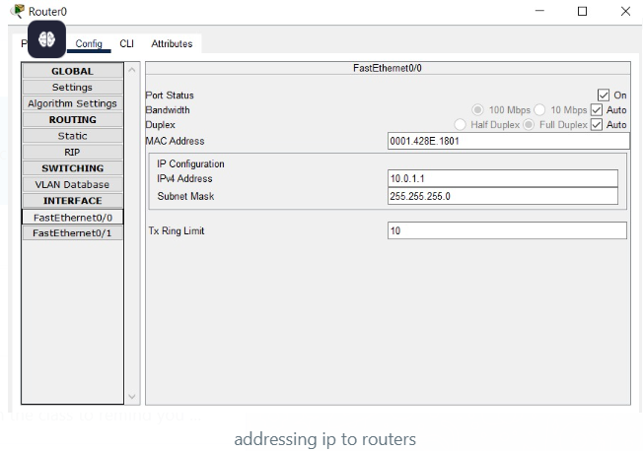

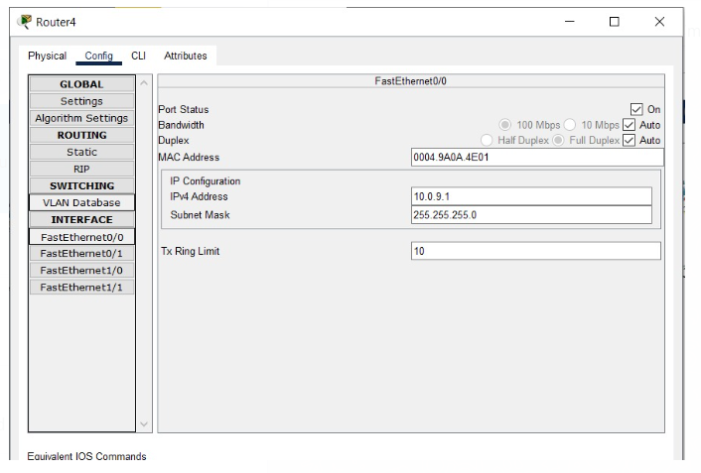

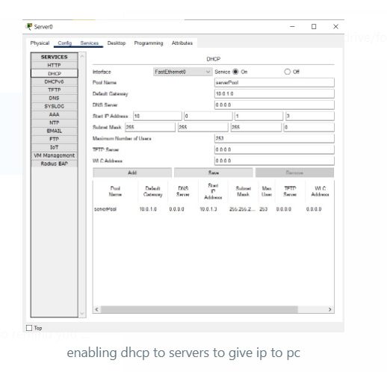

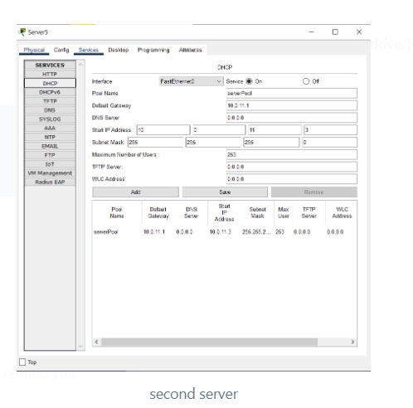

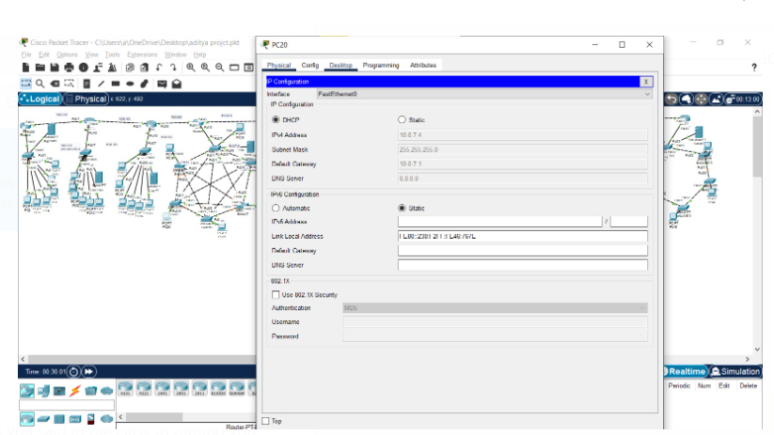

# How you have done the routing. Attach snapshot.

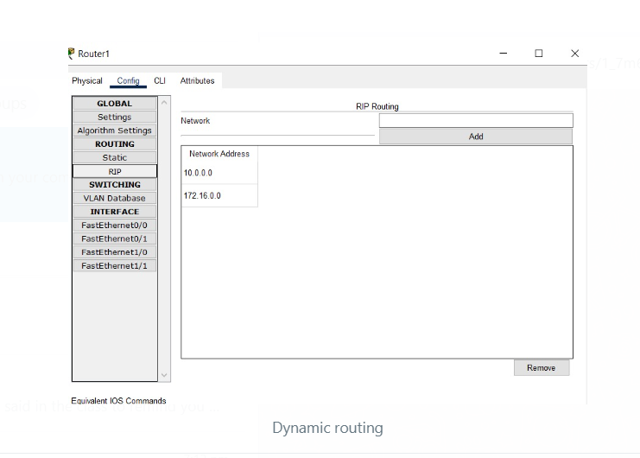

**4. Then show the communication between all pc.**

**Attach snapshot.**

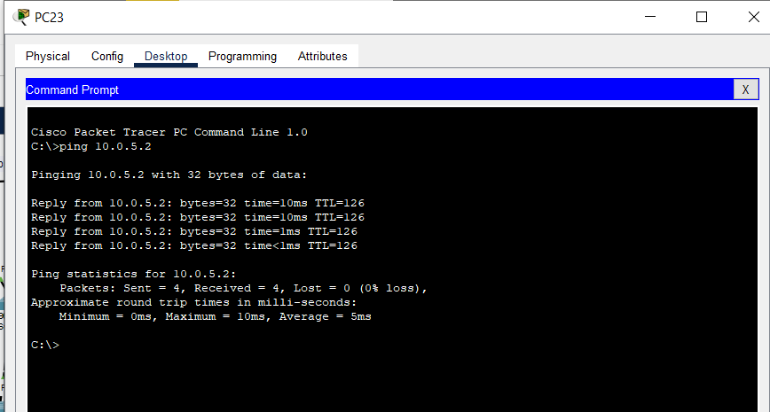

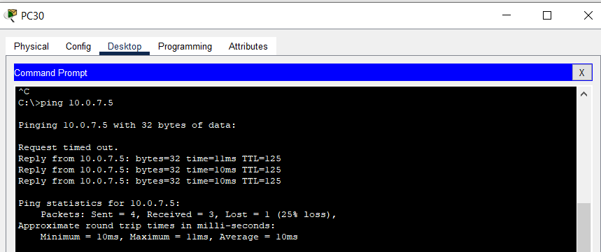

**GitHub Link: -**